**Creating a Requisition for Wegmans Shoppers Club – Business (SCB) PO Card 8.2020**

The District utilizes RCSD, state, county, and other contracts for office supplies, writing instruments, arts and craft supplies, custodial supplies, paper products, early childhood/pre-k items, books and other products. Items that may be purchased under a contract should not be purchased using a Wegmans card.

* **Wegmans does NOT provide PO Extensions**
* **Adding money to a card takes 3 days, 72 hrs. to load $ onto card from the time the req. is received in Purchasing’s workflow.** 
  + **\*Please limit your expedited requests to real emergencies, not for poor planning.**
* **It can take up to 2 weeks for a NEW card to be processed and delivered to the school/dept.**
* **Wegmans does NOT do Pre-Pays for SCB Cards** 
  + **(paying for food today, for an order picked up on a future date).**

What does Pre-Pay mean to Wegmans? A form of payment was provided to be CHARGED OUT/BILLED OUT on the DATE OF SERVICE. If your Card expires on 5/31/2023, then you cannot Pre-Pay for an order with a pick up date AFTER 5/31/2023. (i.e. 6/1/23, 6/15/23, etc.) *Your order must be picked up by 5/31/23.

**Email Megan Cross, RCSD Purchasing,** [**Megan.Coss@rcsdk12.org**](mailto:Megan.Coss@rcsdk12.org)

**Initial Card set-up, Add funds to a current card, Entering in requisition**

**EMAIL ONLY Katie Binazeski, Wegmans,** [**Katie.Binazeski@Wegmans.com**](mailto:Katie.Binazeski@Wegmans.com)

* **To report lost/stolen card, forgot PIN, card balance (reference monthly report 1st)**

**Your email subject line should include Card Embossment & # (lower left corner, starts with 49xx) AND/OR PO#**

**\*\*Emails and phone calls to Katie & Megan from the Clerical staff and not the card holder employee.**

If a lost/stolen card is not reported, all charges will be posted against the purchase order associated with that account.

Due to the closing of our Food Services Catering dept. and the high volume of requests to extend Wegmans Cards for year-end events, we have made some changes to the Wegmans Card requests to make card usage and processing payments more efficient. Grant funded Card expiry dates are extended for 2 extra weeks in June and August. This means that there will absolutely be NO additional extensions for the card. Planning accordingly for expenditures is essential!! TIME IS OF THE ESSENCE FOR RECEIVING RECEIPTS in the PS system. We now have a 2 week window for payment vs. 4 weeks! If not receipted in PS and payment made prior to final reporting, the grant expense may be disallowed.

Best Practice would be to establish a uniform location at your school/location to collect receipts. Inform card holder staff of this place or how to submit receipts to you. We are requesting that staff provide you the receipt within 24 hrs. of the purchase. (see Wegmans Shoppers Club for Business

Purchase Order (PO) Card Procedures sheet). On a WEEKLY BASIS you should receipt the transaction/s in PS. If your account is delinquent in payment over 45 days, the account will go on credit hold, until it is paid in full.

**A FUNDS**

General (“A”) funded purchases must be limited to food and food-related items for culinary and family consumer science programs only, unless funds are donations, which a letter from the donor must specifically states food is an applicable expense under the donation.

**GRANT FUNDS**

Grant-funded purchases must be limited to items specified in the approved grant application. If utilizing grant funds for meal expenditures, you must adhere to the per person meal cost allowable in the grant. If the cost is unknown, you must follow the district’s current per person meal cost (reference- RCSD Meal/Food Purchase Procedure (In-District Meals). Contact Accounts Payable (AP) to obtain document.

1. **DEFINING REQUISITION**

**REQUISITION NAME:**  30 CHARACTERS IN LENGTH-

**Name = “WEGMANS –XX (CARD EMBOSSMENT)**

**CONSISTENT NAMING OF YOUR REQ. WILL ALLOW FOR EASE OF SEARCHING FOR THE PO # FOR INCREASES OR PRINTING OF PO.

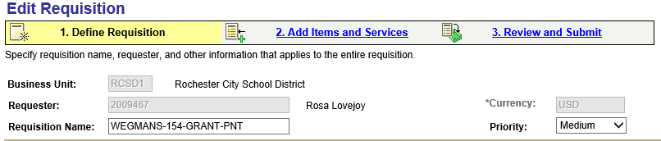

**SAMPLE REQUISITION NAMES:**

**YOUR CARD EMBOSSMENT**

|  |
| --- |
| WEGMANS-261-AFUND-INST |
| WEGMANS-280-AFUND-FCS |
| WEGMANS-123-GRANT-GRHF |
| WEGMANS-123-GRANT-UPK |
| WEGMANS-108-GRANT-PNT |
| WEGMANS-235-GRANT-MAC |

**SAMPLE NEW CARD REQ NAME:**

**NEW CARD MEANS YOU DO NOT HAVE A CARD or LOST THE CARD FUNDED BY THAT BUDGET CODE**

|  |
| --- |
| WEGMANS-#8 SCHOOL-NEW CARD |

**SAMPLE INCREASE TO CURRENT PO REQ NAME:**

|  |
| --- |
| WEG-108-GRANT-PNT INCREASE |
| WEG-235-GRANT-MAC-INCREASE |
| WEG-280-AFUND-FCS-INCREASE |

**Breakdown:**

**VENDOR: #2950**

**CATEGORY: 427 (Meals) or 5500 (Culinary and Family Consumer/Life Skills classes)**

**UNIT OF MEASURE: EA (Each)**

**SHIP TO: Your Location**

**ACCOUNTING DEFAULTS: Your Information**

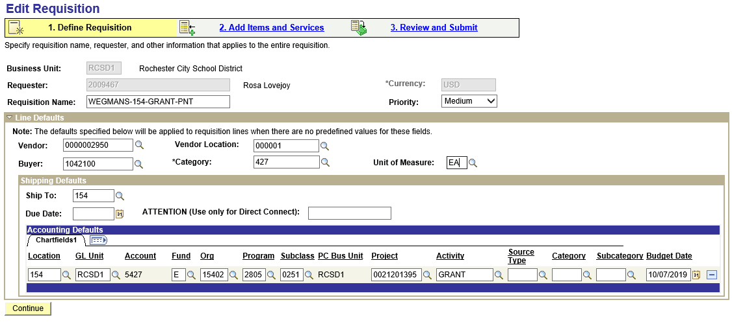

**2. ADD ITEMS AND SERVICES TAB –**

**Special Request / Special Item**

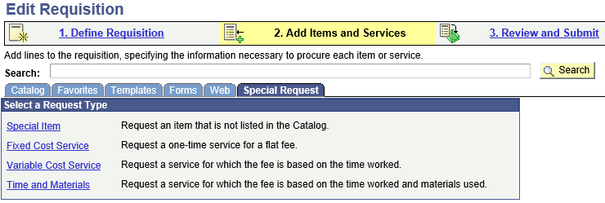

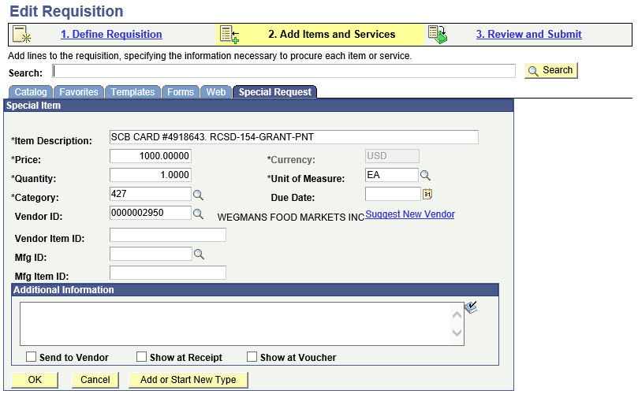

DO NOT CHECK BOXES

**SAMPLE *ITEM DESCRIPTION:**

|  |
| --- |
| SCB CARD #491234 RCSD-123-AFUND-FCS |
| SCB CARD #491234 RCSD-123-GRANT-PNT |
| SCB CARD #491234 RCSD-123-GRANT-GRHF |
| SCB CARD #491234 RCSD-133-GRANT-PREK |

**Breakdown:**

**SCB CARD #** (Shoppers Club for Business (SCB) Card# 4950168-1, Bottom left corner)

**RCSD-116-GRANT-3YR** (Card embossment)



EMBOSSMENT

SCB CARD #49XX

**REVIEW AND SUBMIT TAB**

**JUSTIFICATION/COMMENTS BOX**

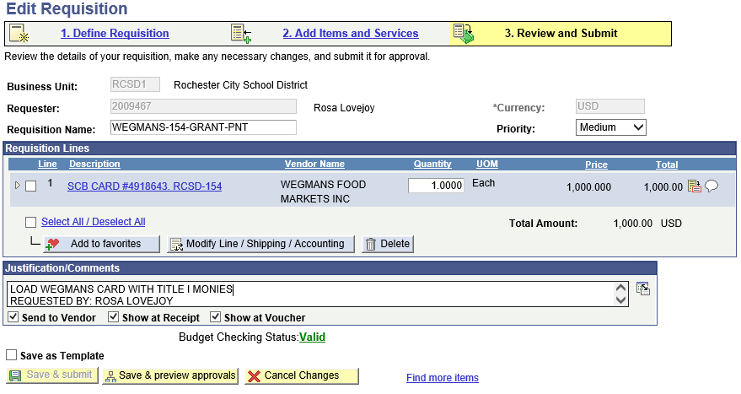

Check all # boxes

**If you are loading a current card, state that you are loading, with the type of funding.**

**OR**

**If you need a new card, please state so in this box. List what the program name is.**

**OR**

**If you misplaced/lost a card, please state so in this box and provide the embossment or what you think the embossment was.**

**OR**

**If this is an increase to a current PO, include the PO # 2024xxxxxx that you want to increase**

**SAMPLE JUSTIFICATION/COMMENTS BOX**

|  |
| --- |
| LOAD WEGMANS CARD WITH TITLE I MONIES  REQUESTED BY: ROSE LOVEJOY |
| THIS REQUIRES A NEW CARD FOR A SPECIAL UPK PROGRAM  REQUESTED BY: JUDY BROWNE |
| THIS REQUEST IS FOR A LOST/REPLACEMENT CARD. RCSD-150-GRANT-PREK  REQUESTED BY: JILL HAROLD |
| THIS IS AN INCREASE TO PO# 2024xxxxxx.  REQUESTED BY: LISA CUMMINGS |

**SAVE & PREVIEW APPROVALS**

**CHECK BUDGET**

Error messages and what they mean:

**WARNING:**

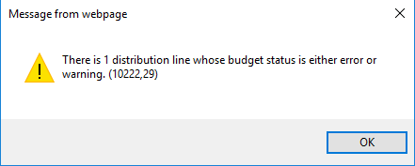

Can mean that the line is set up but not enough money and it will pull from another line. In this case it was 5427 for Meals. This is a Warning and will still allow you to submit. You may want to contact your budget tech to ensure you are set for next time.

**FAIL BUDGET CHECK:**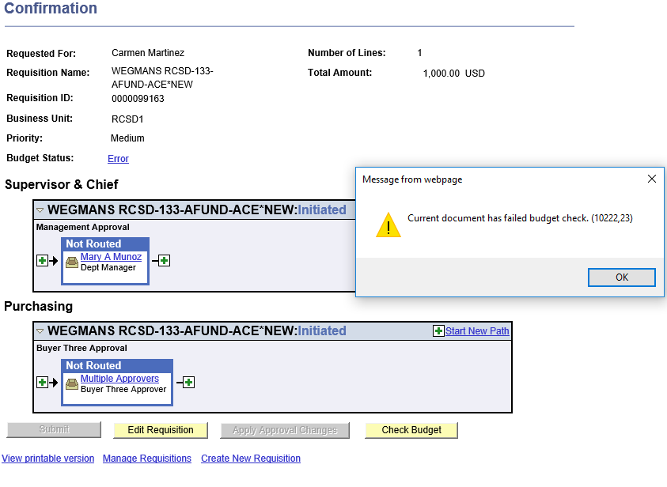

Click to see details

xes

**CLICK: Error to see details**

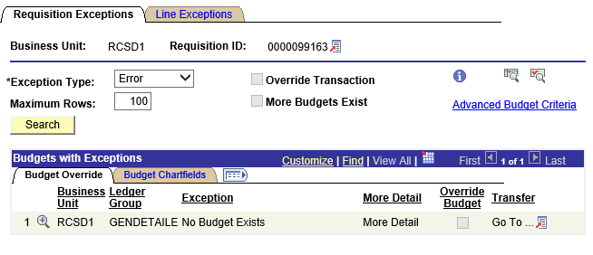

**“No Budget Exists”**

You do not have the budget line open. Please contact your budget tech to open the line for you. Once the line is open, Re-check the budget again.

**SAVE & SUBMIT**

**Manage Requisition**

**-To confirm status of your req.**

**Option #1 SEARCH BY YOUR REQ. NAME (“154”)**

**CLICK ( >) UNDER THE REQ. ID # THIS WILL EXPAND THE DETAILS OF THE REQ.**

**OR**

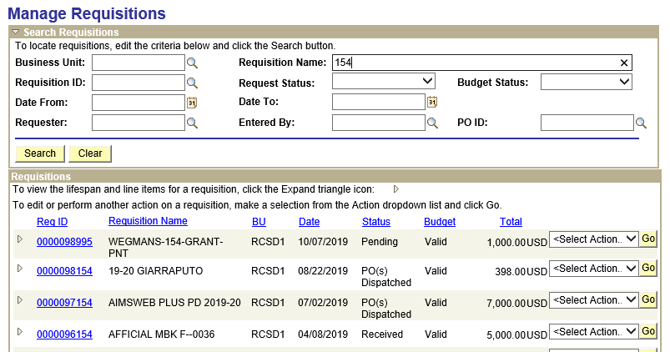

**Option #2 SEARCH BY REQ. NUMBER**

**CLICK ( >) UNDER THE REQ. ID # THIS WILL EXPAND THE DETAILS OF THE REQ.**

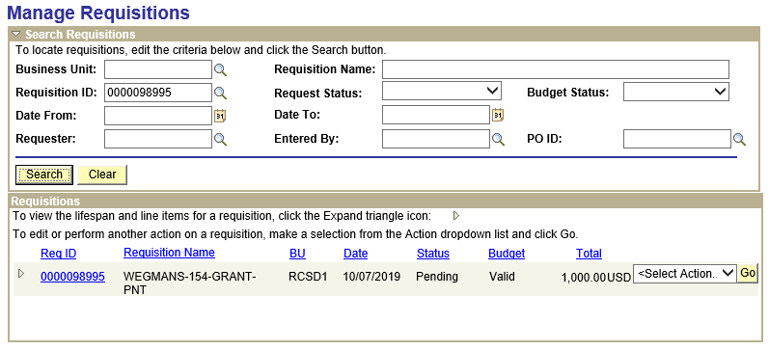

**HIGHLIGHTED BLUE IS THE STATUS OF “APPROVALS”**

**CLICK “APPROVALS” TO HAVE THE APPROVALS SCREEN OPEN UP.**

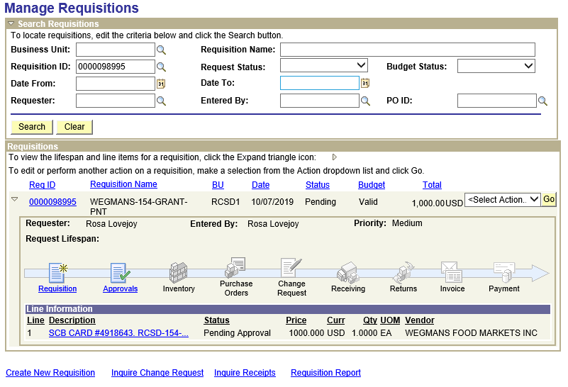

**THIS REQ. IS PENDING “PURCHASING” APPROVAL ON 10/7/2019 @ 5:25PM**

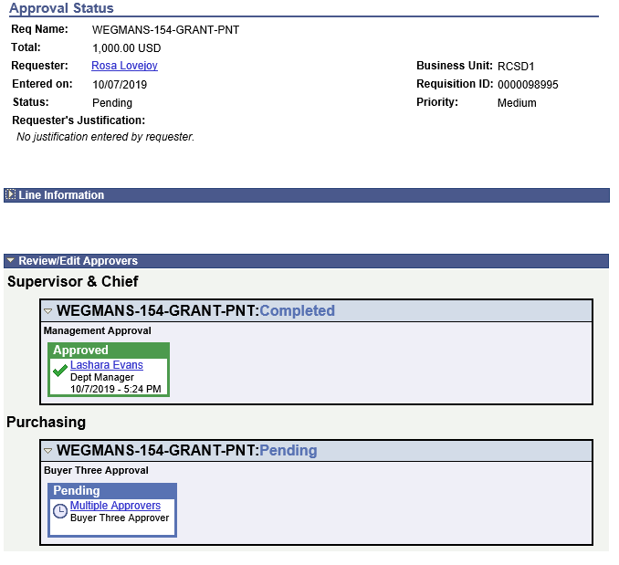

Once the PO is issued, you may want to print a few copies to keep on file. Maintain one with the monthly control log and provide one to the Teacher/Staff that utilizes the card or each time you hand out the card.

*\*See Printing a Copy of a PO*

**SAMPLE PO - LOAD CARD/1ST LOAD OF YEAR**

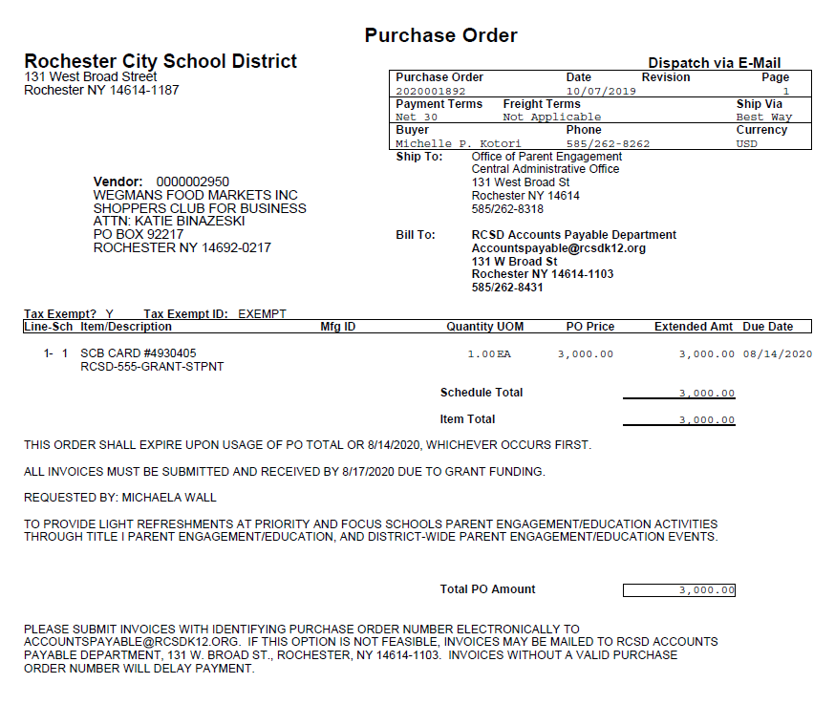

**SAMPLE PO – CHANGE ORDER/INCREASE (SEE ADDED LINE #2)**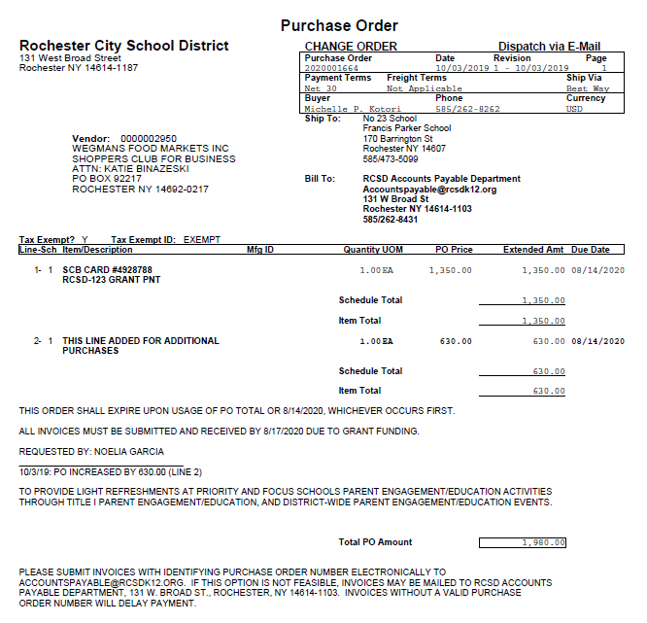

**SAMPLE PO - NEW CARD**

